

**UNIVERSITY OF PETROLEUM AND ENERGY STUDIES**

**School of Computer** **Science**

**2020-21**

**GRAPHICS AND ANIMATION TOOLS LAB**

**Faculty: Dr. DURGANSH SHARMA**

**Assistant Professor**

**Department of Cybernetics.**

**School of Computer Science, UPES**

**Submitted By:**

**Name- Manushi Kapoor**

**Roll no-R100217037**

**Batch-B1**

**Semester- 7**

**Course-B.tech. CSE-OSOS**

**Sap Id- 500062100**

EXPERIMENT - 4

**Aim : Creating an animation in GIMP.**

**Steps to be followed –**

* Select File Menu > Open as Layers > Select all images you want to be in the GIF > Open

I have selected the following three images –

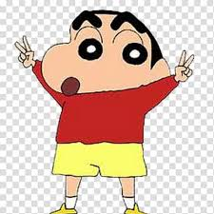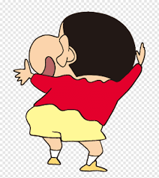

* In layers tab order your images > The GIF sequence will start with your bottom layer and run through each layer bottom to top.
* Select Filters from main menu > Animation > Click Optimize for GIF
* To view GIF > Filter > Animation > Playback
* Save your work as a gif file
* To save GIF > Select File > click Export as
* Name your GIF and choose folder > Select File Type > Click GIF Image
* Select ‘As Animation’ > Select ‘Loop Forever’.
* To change speed between each image change the delay Click Export

Final output is attached.